**Irys, qubit**

**ample preparation**



**Optimization (before run)**

1. 30 min' before the run: take out the samples from the fridge, the chip from the freezer (-20, bottom, white box red sticker)- place in the room (to reach room temp').
2. Open the "Irys" software, choose user- "Yael" , then next (≥).
3. **Sample preparation:** add yoyo, DTT & flow buffer, mix X3 times with wide board tip with a filter, **s-l-o-w-l-y**.
4. Insert the chip into the Irys.
5. **Load chip**: Each inlet and outlet should be filled with 8 ul of sample, or be filled up with UPW to final volume of 8 ul- until the holes are flat. First, load the inlets (make sure there are no bubbles), write under flowcell1 & 2 what they contain, then load the outlets.
6. Oil the lens- use the designated oil.
7. **Focus step**: (1) Fiducial (2) Position 1 (3) Position 2:
   1. Fuducial: Place the red circle in the middle, Set Fiducial, Find position 1
   2. Position 1: Place the red circle on the cross, Set Position 1, Find position 2
   3. Position 2: Place the red circle on the cross, Set Position 2, next (≥)
8. **Choose a recipe**:
   1. FlowCell1: "generate optimization A"
   2. FlowCell2: "generate optimization B"
   3. Choose the cycle amount (scans per run).
   4. Select lasers (red, green)
   5. Insert the sample concentration time.
9. Select recipe to use as a base- M3. During this time the sample is being concentrated before the bump step. Overshooting- when the molecules pass the bump line, in case it happens often, the voltage must be decreased (normally the voltage is set to 30V, each click on OK decreases it by 5V).
10. **Bump time optimization**: Once the bump has started, one must click OK just before molecules arrive to the pillars (~10-20 sec), then, repeat the bump process again (concentration of DNA then bump), then use the average bump time.
11. **Run time optimization**: once bump time was optimized, load time is optimized (this is the time where molecules pass from wide nanochannels to narrow nanochannels, ~10 minutes). "Perform final load measurement?" - OK, then after ~30-40 sec, the molecules appear- immediately click OK.
12. Now the Irys will run the molecules and present an image of the results, if it is ok, give a name to the protocol, and move on to optimize FlowCell2.
13. Once optimization for FlowCell2 is also finished, scans will take place.

**Rehydration**

1. "Pause run", wait for "Rehydration/oil" button to become available.
2. Click "Rehydration/oil", the Irys chamber will open:
   1. Clean the bottom of the chip: use designated paper tissue, "optical lens cleaner". Make sure it is cleaned underneath.
   2. Clean the lens- use the designated tissue and cleaner, if one tissue is not enough use another.
   3. Add Oil to the lens.
   4. Add UPW to the chip- use a small tip, a simple touch may do.
3. Next (≥).
4. Repeat focus step (#7).

**Closing the program, cleaning chip**

1. Once the program ends, click Next (≥).
2. The chamber will open, Remove your chip.
3. Add the "cleaning chip" (in the placard above the Irys), add into it 250ul UPW.
4. Follow the instructions and mark V after performing all tasks.
5. The chamber will be closed for 5 minutes in order to clean the electrodes.
6. Click on "dry chamber"- the chamber will be opened for 5 minutes, remove the cleaning chip.
7. Exit the Irys software, restart the computer.

**Chip recycling**

1. Remove all the samples from the chip.
2. Add to each well 7 ul of TRIS 10mM
3. Add 1 ul of Benzonase to each well, pipet a bit (endonuclease, digests the DNA and therefore facilitating the chip cleaning process).
4. Return the chip to its bag, every day add TRIS 10mM if necessary.

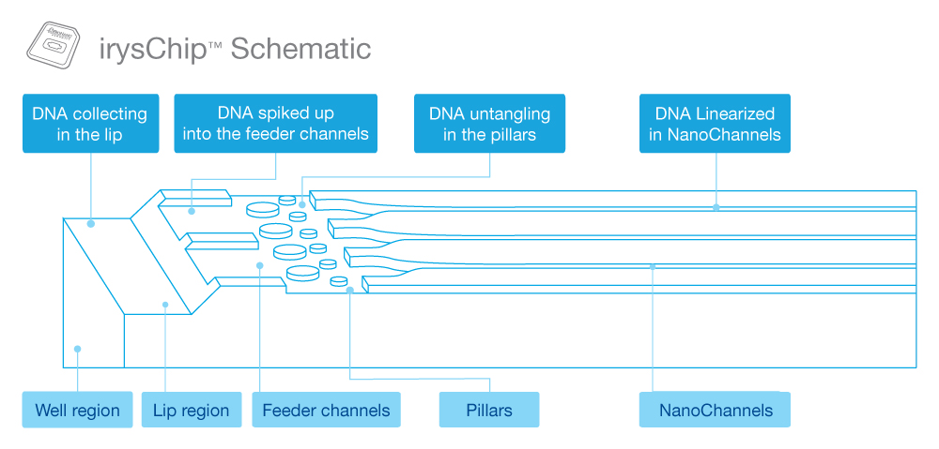

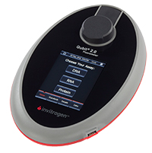

**Qubit (invitrogen)** - for precise measurements of DNA concentrations

** The qubit is placed in the drawer between Yael & Shahar .

** The qubit 's kits are placed in the old fridge, 3rd drawer, 2 kits:

1. High sensitivity (we will normally use this one).
2. Broad range

1. First, prepare the kit reaction mix (instructions are placed with the qubit). Make sure to always make enough reaction mix (prepare an amount that will suffice for one extra sample).
2. For each DNA sample, use 3 qubit tubes - you will have to measure the sample top, middle, bottom.
3. There are also 2 standard solutions, used in each run of the qubit to calibrate it (so make sure to take these 2 additional samples under account when making the reaction mix).
4. Preparing the sample:
   1. mix X3 times, use a with wide board tip with a filter, **s-l-o-w-l-y**.
   2. Using the qubit pipettors, take 2 ul from the top of the sample, place in a qubit tube. Repeat this action with two additional qubit tubes, take 2 ul from the middle and from the bottom.
   3. Add 18 ul of reaction mix into each tube, vortex, spindown then place in the sonicator for 10 minutes.
   4. After 10 minutes, add 180 ul of reaction mix into each tube.
   5. Prepare the standard tubes according to the instructions.
5. Vortex and spindown all samples, let them "rest" for 5 minutes.
6. Place them in the qubit in the same orientation. Important note: When measuring your sample, make sure to place the correct stock amount (in this case 2ul)
7. Once the measure is over, use google to calculate the CV (coefficient variance), mean and STDEV. A good CV is under 16%.